Wiebes' Wavelength
Child Evangelism Fellowship® Atlantic Canada February 2022

Dear Friends:
In our December prayer letter, we talked about Jesus finding a home in our heart and lives. I know each of us wants Him to be part of our lives, but sometimes we’re just too busy to include Him. He’s a part—but rather lost in the shuffle of our busyness. I’ve been sorting through boxes of things and came across this in an old church bulletin I saved since my teen years—so 45 years old for sure, but still pertinent.

“Study to be quiet.” I Thessalonians 4:11

“This is an agitated world. Frustration and restlessness is on every hand. We seem to be always on the move, unable to tolerate our own company. When at last we do get alone, we cannot turn off our motors. It is an age of MUCH ADO ABOUT NOTHING. Results—Nervous breakdowns, broken homes and heart attacks.
Is there a cure? Yes. “Study to be quiet.” Again, the Word says, “Be still and know that I am God.”
In quietness there is power. Have you ever noticed the morning as it opens the door for the day to enter, or watched the evening draw the curtains of night? No noise, but what power! How noiselessly the dewdrops fall
upon the bosom of the rose.

Quiet things are eloquent.
How can we get quiet in this complex life? We need a new center and that center mut be Christ.
We are not here just to wear our boots out. Paul was a busy man, but he learned the secret of living in the Unseen. It is only as we, too, learn this secret that our lives become effective for Him.
We hurry and hustle, we sweat and toil, Till we’re weary almost to death—But out of the chaos of time and tide, God speaks and our souls find rest.
The pause that refreshes is in God’s hand—He wants us in His love to bask.
So soul, if you’re wary and tired and spent, Pause—be made fit for your task.”
--Glenn Wagoner

Another year has started and to our dismay, another year with covid restrictions. For some of you, maybe it doesn’t stress you out or irritate you. But it does me. I don’t know why precisely, but it does. So, that’s why this little scrap of advice, that obviously I found helpful back when I was making huge, life changing decisions, still resonates with me. There is no date on the bulletin, but it would have been in the 3 years during which I was searching for what to do after High school. I wanted to be a doctor--my dad wanted me to go to Bible College. Where to go, what to do? I decided to do one year of Bible college--my dad asked me to graduate from there before pursuing medical training. Then my father died and I had 2 younger brothers under 18. The laws at the time stated they were too old for foster care, so the only place for them was the Zebulun Pike Reformatory. I battled in the courts for over a year to become their guardian. Life was stressful, but God is faithful. So, I kept the scrap of paper as a reminder.

This year, Ron and I are facing more decisions. Not as hard, but still life changing. We love our work, but there is always the need to be replaced by someone younger. Please pray with us for the person of God’s choice to work for Child Evangelism Fellowship of Atlantic Canada. Thanks. Now come the questions: What to do, when to do it, where to go, what will the future look like? In which direction will God lead us? We would appreciate your prayers as we try to look at all the many facets of this new phase of our lives. This doesn’t in any way mean we want to quit ministering or working with children! We just feel the time has come for a change. Our age is catching up with us! This can be an exciting time for us, or stressful. Hence the need to “study to be quiet” and “Be still and know that I am God” (Psalm 46:10).

On the ministry side of things, I would appreciate your prayers as I work
with the Canada wide committee, helping to develop this summer’s VBS
kit. Thanks. There are a lot of details that need to be determined before
this becomes viable. Please pray above all that the contents of this VBS
would glorify God and promote His Kingdom, His love and His salvation. Thanks!

Please contact us if you are interested in this VBS—in person at your church and which week would be best for you; online for the children in your church; DVD for the children in your area; on Zoom with other children across Canada. Thanks. Call Ron at: 506 375 4775.

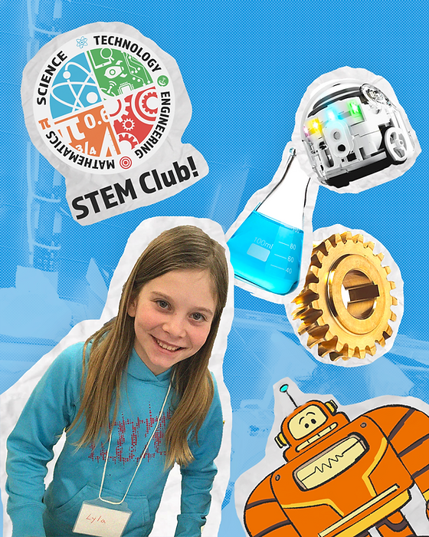
CEF of Ontario has a special program called STEM Clubs to
Gospel-centred curriculum
- 24 week CEF Bible lesson plan
- 4 STEM Stories
- 8 worship songs with visuals
- Memory verses
- Big Idea books
- 4 books
- 20 copies of each

use with children on your weekly club nights. STEM
stands for: Science, Technology, Engineering and
Math. Bible lessons are paired with concepts from
these 4 areas to show the children how the Bible is
viable in their daily lives. The program includes
games/activities for the children to participate in,
which takes the place of regular game/gym
time. These activities are based on the STEM concepts
as well. Contact us for more details or CEF Ontario at www.cefontari.org/stem-club or call 519 751 1233 during their office hours and they would love to help you!

On a personal note, our daughter Kendra, who lives in the States with her family, will be presenting us with our 10th grandchild anytime in the next few weeks. We are excited! We make sure to give you all the details in our next letter.

Life goes on. Stress is a part of it. Changes come and go. The one constant is Jesus. I will seek to “study to be quiet” and remember to “be still and know that He is God.” Nothing in my life has taken God by surprise. We can trust Him to handle all the details of the changes that will come. Will you trust Him with yours as well?

Love,

Ron and Eunice Wiebe
CEF of Canada CEF International CEF Atlantic
Box 165 Stn Main Box 348 Warrenton 75 Fownes Rd
Winnipeg MB R3C 2G9 MO 63383-0348 Weldon NB, E4H 4P3
(for US donars use: Ron Wiebe Acct # 03775-23

